

***INSTITUTE OF INFORMATION TECHNOLOGY***

***JAHANGIRNAGAR UNIVERSITY***

**Number of Assignment :** 01

**Submission Date :** 31/01/2024

**Course Tittle :** Digital Image Processing

**Course Code :** ICT - 4201

**Submitted To Submitted By**

Fahima Tabassum Group – 23

Professor 2023 - Md. Shakil Hossain

IIT – JU 2024 - Mahbubur Rahman

2028 - Nahidul Islam

This is a problem about applying arithmetic mean filters to an image of white bars.

**3x3 filter**: A 3x3 filter takes the average of the 9 pixels in a 3x3 neighborhood around each pixel. Applying this filter to the image of white bars would result in a slight blurring effect, as the edges of the bars would become less sharp and more gray. The width and height of the bars would also decrease slightly, as some of the white pixels would be averaged with the black pixels around them. The resulting image would consist of vertical bars that are about **5 pixels wide** and **208 pixels high**, with rounded corners and gray borders.

**7x7 filter**: A 7x7 filter takes the average of the 49 pixels in a 7x7 neighborhood around each pixel. Applying this filter to the image of white bars would result in a more pronounced blurring effect, as the edges of the bars would become more diffuse and lighter. The width and height of the bars would also decrease more, as more of the white pixels would be averaged with the black pixels around them. The resulting image would consist of vertical bars that are about **3 pixels wide** and **204 pixels high**, with very rounded corners and light gray borders.

**9x9 filter**: A 9x9 filter takes the average of the 81 pixels in a 9x9 neighborhood around each pixel. Applying this filter to the image of white bars would result in a very strong blurring effect, as the edges of the bars would become almost indistinguishable from the background. The width and height of the bars would also decrease significantly, as most of the white pixels would be averaged with the black pixels around them. The resulting image would consist of vertical bars that are about **1 pixel wide** and **200 pixels high**, with barely visible corners and very light gray borders.

**Python Code:**

import cv2

import numpy as np

# Load the image as grayscale

img = cv2.imread('white_bars.png', cv2.IMREAD_GRAYSCALE)

# Define the kernels for 3x3, 7x7, and 9x9 filters

kernel_3x3 = np.ones((3, 3), np.float32) / 9

kernel_7x7 = np.ones((7, 7), np.float32) / 49

kernel_9x9 = np.ones((9, 9), np.float32) / 81

# Apply the filters using cv2.filter2D function

img_3x3 = cv2.filter2D(img, -1, kernel_3x3)

img_7x7 = cv2.filter2D(img, -1, kernel_7x7)

img_9x9 = cv2.filter2D(img, -1, kernel_9x9)

# Display the original and filtered images

cv2.imshow('Original', img)

cv2.imshow('3x3 filter', img_3x3)

cv2.imshow('7x7 filter', img_7x7)

cv2.imshow('9x9 filter', img_9x9)

cv2.waitKey(0)

cv2.destroyAllWindows()

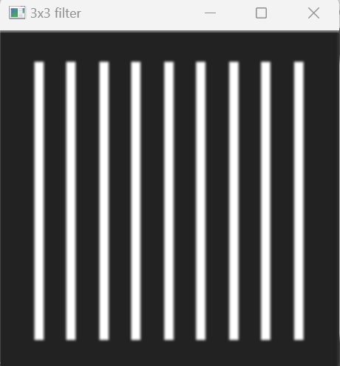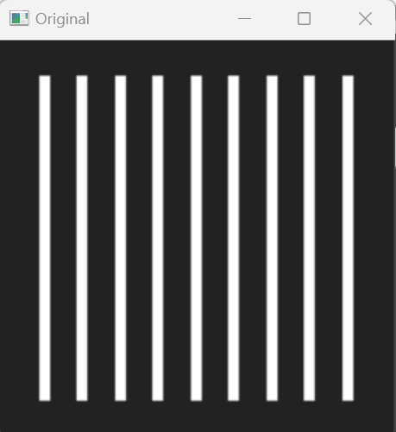**Output:**

